Local Council Elections 2019 - Age Friendly Campaign
Ask candidates in your area to pledge to be an Age Friendly Champion in your council

On May 2nd 2019 voters in Northern Ireland will go to the polls to elect Councillors to represent them in their Council areas. Election time provides an opportunity to seek a commitment from candidates about what you would like them to deliver for you if they are elected.

For this election we are asking candidates to pledge that, if elected, they will work to promote and galvanise “Age Friendly” work within their councils. We have chosen this campaign topic because older people have told us it is important to them.

What Age Friendly means

Age Friendly is a framework developed by the World Health Organisation (WHO) to support the development of Age Friendly communities. An age friendly world enables people of all ages to actively participate in community activities and treats everyone with respect, regardless of their age. It is a place that makes it easy for older people to stay connected to people and things which are important to them. It also helps people stay healthy and active even at the oldest ages and provides appropriate support to those who can no longer look after themselves.
The framework outlines eight themes to consider when developing plans.

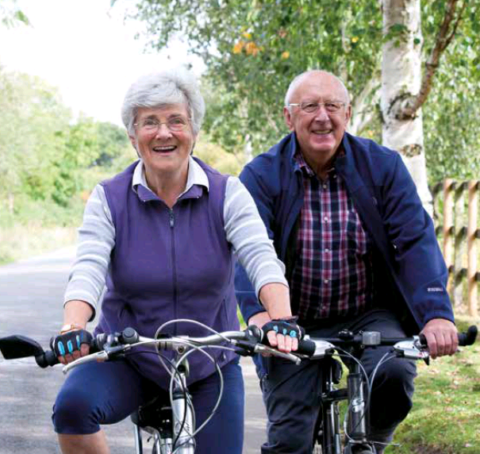
These are:
- Civic Participation & Employment
- Communication & Information
- Social Participation
- Outdoor Space & Buildings
- Transportation
- Respect & Social Inclusion
- Housing
- Community Support & Health Services

In practical terms, age-friendly environments are free from physical and social barriers and are supported by policies, systems, services, products and technologies that:
- promote health and build and maintain physical and mental capacity across the life course and
- enable older people, to continue to do the things they value.

Why does Northern Ireland need Age Friendly communities?
Living longer is a huge opportunity if we prepare and plan for our ageing population and take steps to ensure our neighbourhoods and communities are welcoming, accessible and inclusive places for us all to age well in. As we grow older, we may spend more time in our homes and neighbourhood, so our environment has a significant impact on our health, wellbeing and the quality of our lives.

There is a real need to work together to remove the barriers older people face to participating in the life of their local communities. Where we live and its immediate environment sets the tone for our daily life and, while many older people continue to play an active part in their community, lack of accessible local transport options, somewhere to sit down, or access to clean public toilets limits how far people are able to get around. Poor quality pavements, inadequate street lighting or fear of crime can stop people feeling confident enough to go out.

Age Friendly places are essential for us all as we age, as consumers, as volunteers, workers and as care givers. As our population ages, ensuring that those who are less mobile or not online are not left behind will be vital.

What role will newly elected Councillors have?

In the Active Ageing Strategy Government set out a framework to plan and prepare for our ageing population: ‘Northern Ireland being an Age Friendly region in which people, as they get older, are valued and supported to live actively to their fullest potential; with their rights respected and their dignity protected’.

There are a range of age friendly practices across Northern Ireland, with some councils more advanced with Age Friendly plans while others have yet to sign up to an Age Friendly declaration.

Following the election, councillors will have a key role to play in promoting Age Friendly and supporting your council in the development and implementation of Age Friendly plans and initiatives for your area.

We believe that everybody should be able to live in an age-friendly world that enables people of all ages to participate in the life of their local community, connected to each other and to opportunities in their local area, valued for the contribution they can and do make to their local community. This is why we are seeking commitment from election candidates in the form of a pledge.

You can help support us in our campaign by taking the actions overleaf.

Things you can do to support the campaign

- On the doorstep – ask candidates to sign the pledge
We are calling upon candidates in the 2019 local election to pledge that, if elected, they will be “Age Friendly Champions” in their councils. When candidates are out canvassing ask them to sign the pledge. You can cut out copies of the pledge to give to candidates or display where candidates will see it when out canvassing.
Copies of the pledge card sheet are also available to download here: www.ageni.org/electioncampaign

The Pledge

We call upon election candidates to pledge a commitment that, if elected, they will play an active role in working to promote Age Friendly, in their council and in the communities it serves.

By signing the pledge to be an Age Friendly Champion, candidates agree to…

- Promote and support good Age Friendly practice and planning in your council.
- Engage with older people’s groups and networks. Listen to, understand and act on older people’s views to improve their neighbourhood.

- Drive engagement and coproduction with older people at community level.
- Encourage and adequately resource Age Friendly initiatives that improve older people’s wellbeing and connections and reduce loneliness and social isolation.

- Support council staff in their work advancing Age Friendly planning practices and partnerships.

- Encourage Age Friendly partnerships to explore evidence based, intergenerational approaches to creating great places to grow old for everyone.

- Value the contribution older people make in their communities.

SIGN UP HERE: www.ageni.org/electionpledge

Use this hashtag on social media to show your commitment #agefriendlychampion

- Write to the Candidates in your constituency
Councils must provide a list of all candidates on their website, these documents are called ‘Statement of persons nominated and notice of poll”. There is one for each electoral area and they list the names, postal addresses and political affiliations (if any) for each candidate, in each area. You could write to the candidates in your District Electoral Area (DEA) highlighting the campaign and why Age Friendly communities are important to you.
You can find a links to these documents on our website here: www.ageni.org/electioncampaign

Michele Smyth, Senior Campaigns & Communications Officer, Age NI, 3 Lower Crescent, BELFAST, BT7 1NR. Tel: 028 90 245 729 Email:michele.smyth@ageni.org

http://www.who.int/ageing/age-friendly-world/en/
https://www.communities-ni.gov.uk/publications/active-ageing-strategy-2016-2021

