Local Council Elections 2019 Age Friendly Campaign
Pledge to be an Age Friendly Champion in your council
Age NI is the leading charity in Northern Ireland dedicated to helping everyone make the most of later life. We work in partnership with a range of organisations to highlight what really matters to older people. Our aim is to bring about positive change. We call upon candidates in the 2019 local election to pledge that, if elected, they will be “Age Friendly Champions” in their councils.

In the Active Ageing Strategy Government set out a framework to plan and prepare for our ageing population: ‘Northern Ireland being an Age Friendly region in which people, as they get older, are valued and supported to live actively to their fullest potential; with their rights respected and their dignity protected’.

As a councillor you will have a key role to play in promoting Age Friendly and supporting your council in the development and implementation of Age Friendly plans for your area. We believe that everybody should be able to live in an age-friendly world that enables people of all ages to participate in the life of their local community, connected to each other and to opportunities in their local area, valued for the contribution they can and do make to their local community.

We call upon election candidates to pledge a commitment that, if elected, they will play an active role in working to promote Age Friendly in their council and in the communities it serves.
SIGN UP HERE: www.ageni.org/electionpledge
Use this hashtag on social media to show your commitment: #agefriendlychampion

Why does Northern Ireland need Age Friendly communities?
Preparing and planning for an ageing population

In Northern Ireland, our society is ageing. Population projections from NISRA indicate that in the 25 years from 2014 – 2039, the numbers of people aged 65 and over will increase by 74.4% or 498,500 people, and that those aged 85 and over will increase by 157.3% or 54,200 people. It is projected that by 2039, 24.7% of the population will be aged 65 and over, and 18.4% will be under the age of 18. These demographic shifts will have significant impacts for our communities, for public policy, for service providers and for the economy. The United Nations called global population ageing ‘a situation without parallel in the history of humanity’ in its 2002 report World Population Ageing1950-2050.

Living longer is a huge opportunity if we prepare and plan for our ageing population and take steps to ensure our neighbourhoods and communities are welcoming, accessible and inclusive places for us all to age well in. As we grow older, we may spend more time in our homes and neighbourhood, so our environment has a significant impact on our health, wellbeing and the quality of our lives.

There is a real need to work together to remove the barriers older people face to participating in the life of their local communities. Where we live and its immediate environment sets the tone for our daily life and while many older people continue to play an active part in their community, lack of accessible local transport options, somewhere to sit down, or access to clean public toilets limits how far people are able to get around. Poor quality pavements, inadequate street lighting or fear of crime can stop people feeling confident enough to go out.
Age Friendly communities are essential for us all as we age, as consumers, as volunteers, workers and as care givers. We will need to ensure that those who are less mobile or not online are not left behind.

What Age Friendly means

Age Friendly is a framework developed by the World Health Organisation (WHO) to support the development of Age Friendly communities. An age friendly world enables people of all ages to actively participate in community activities and treats everyone with respect, regardless of their age. It is a place that makes it easy for older people to stay connected to people and things which are important to them. It also helps people stay healthy and active even at the oldest ages and provides appropriate support to those who can no longer look after themselves. The framework outlines eight themes to consider when developing Age Friendly plans.
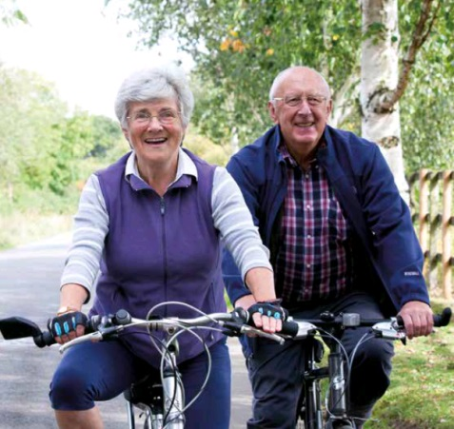
These are:
- Civic Participation & Employment
- Communication & Information
- Social Participation
- Outdoor Space & Buildings
- Transportation
- Respect & Social Inclusion
- Housing
- Community Support & Health Services

In practical terms, age friendly environments are free from physical and social barriers and are supported by policies, systems, services, products and technologies that:
- promote health and build and maintain physical and mental capacity across the life course and
- enable older people, to continue to do the things they value

As an Age Friendly Champion you agree to…

- Promote and support good Age Friendly practice and planning in your council.
- Engage with older people’s groups and networks. Listen to, understand and act on older people’s views to improve their neighbourhood.

- Drive engagement and coproduction with older people at community level.
- Encourage and adequately resource Age Friendly initiatives that improve older people’s wellbeing and connections and reduce loneliness and social isolation.

- Support council staff in their work advancing Age Friendly planning, practices and partnerships.

- Encourage Age Friendly partnerships to explore evidence based, intergenerational approaches to creating great places to grow old for everyone.

- Value the contribution older people make in their communities.

CONTACT:
Michele Smyth, Senior Campaigns & Communications Officer, Age NI, 3 Lower Crescent, BELFAST, BT7 1NR. Tel: 028 90 245 729 Email:michele.smyth@ageni.org

https://www.communities-ni.gov.uk/publications/active-ageing-strategy-2016-2021
2014 Based Population Projections for Northern Ireland, NISRA (https://www.nisra.gov.uk/publications/2014-based-population-projections-northern-ireland )
http://www.un.org/esa/population/publications/worldageing19502050/
http://www.who.int/ageing/age-friendly-world/en/

